HMM Assignment

**C** **grade**

1)

* For T = 1000

WITH TIME LIMIT

time limit: 0.9s

time limit: 9s



WITHOUT TIME LIMIT

Converge after 956 iterations

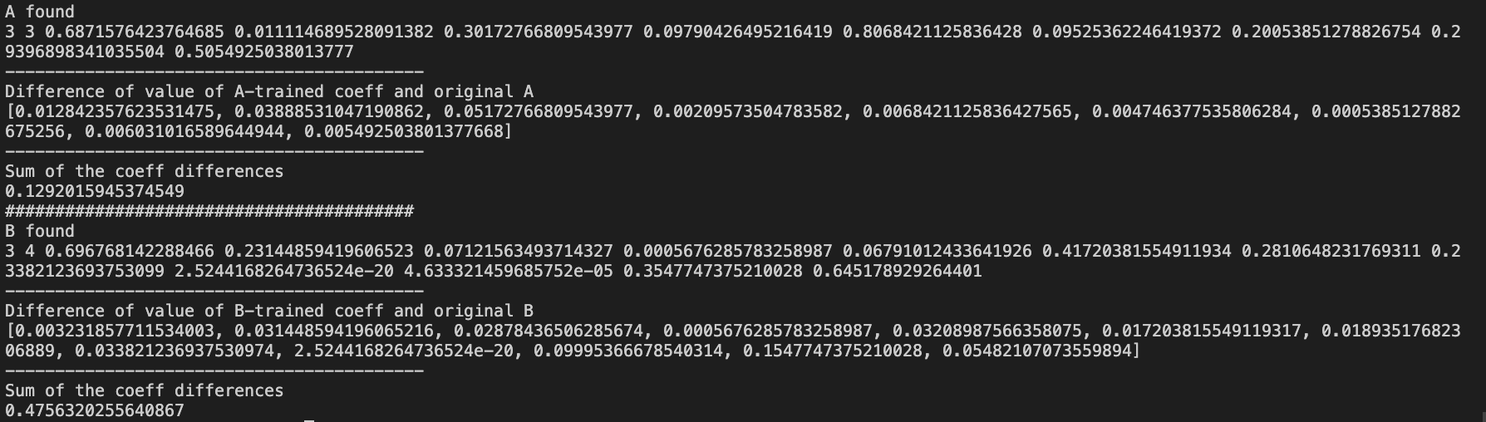

It converges but without a great accuracy.

* For T = 10000

Time limit: 0.9s



Time limit: 9s

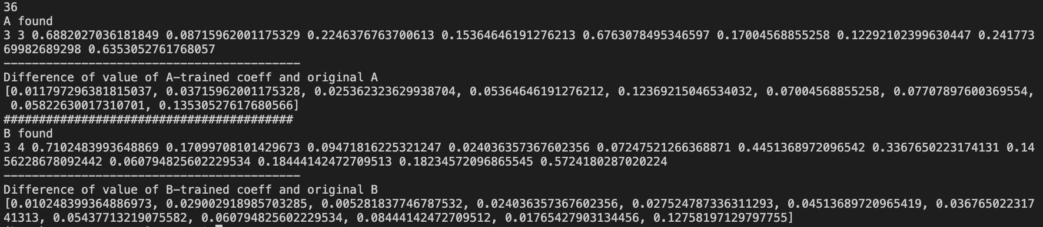

WITHOUT TIME LIMIT

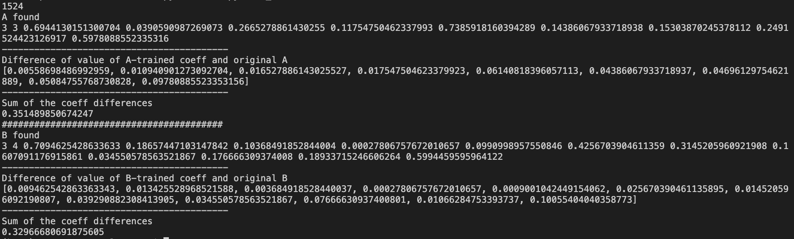

Takes 5 min to converge

Not great accuracy neither

A found

3 3 0.6871576423764685 0.011114689528091382 0.30172766809543977 0.09790426495216419 0.8068421125836428 0.09525362246419372 0.20053851278826754 0.29396898341035504 0.5054925038013777

------------------------------------------

Difference of value of A-trained coeff and original A

[0.012842357623531475, 0.03888531047190862, 0.05172766809543977, 0.00209573504783582, 0.0068421125836427565, 0.004746377535806284, 0.0005385127882675256, 0.006031016589644944, 0.005492503801377668]

#########################################

B found

3 4 0.696768142288466 0.23144859419606523 0.07121563493714327 0.0005676285783258987 0.06791012433641926 0.41720381554911934 0.2810648231769311 0.23382123693753099 2.5244168264736524e-20 4.633321459685752e-05 0.3547747375210028 0.645178929264401

------------------------------------------

Difference of value of B-trained coeff and original B

[0.003231857711534003, 0.031448594196065216, 0.02878436506285674, 0.0005676285783258987, 0.03208987566358075, 0.017203815549119317, 0.01893517682306889, 0.033821236937530974, 2.5244168264736524e-20, 0.09995366678540314, 0.1547747375210028, 0.05482107073559894]

(base) p14-n2:C comelassarat$ python3 HMM.py < Q1_10000.in

1524

A found

3 3 0.6944130151300704 0.0390590987269073 0.2665278861430255 0.11754750462337993 0.7385918160394289 0.14386067933718938 0.15303870245378112 0.2491524423126917 0.5978088552335316

------------------------------------------

Difference of value of A-trained coeff and original A

[0.00558698486992959, 0.010940901273092704, 0.016527886143025527, 0.017547504623379923, 0.06140818396057113, 0.04386067933718937, 0.04696129754621889, 0.05084755768730828, 0.09780885523353156]

#########################################

B found

3 4 0.7094625428633633 0.18657447103147842 0.10368491852844004 0.00027806757672010657 0.0990998957550846 0.4256703904611359 0.3145205960921908 0.1607091176915861 0.034550578563521867 0.176666309374008 0.18933715246606264 0.5994459595964122

------------------------------------------

Difference of value of B-trained coeff and original B

[0.009462542863363343, 0.013425528968521588, 0.003684918528440037, 0.00027806757672010657, 0.0009001042449154062, 0.025670390461135895, 0.014520596092190807, 0.039290882308413905, 0.034550578563521867, 0.07666630937400801, 0.01066284753393737, 0.10055404040358773]

🡪 having more observations doesn’t seem to affect much accuracy

Converge when P(O | λ) increases

2)

* T = 1000

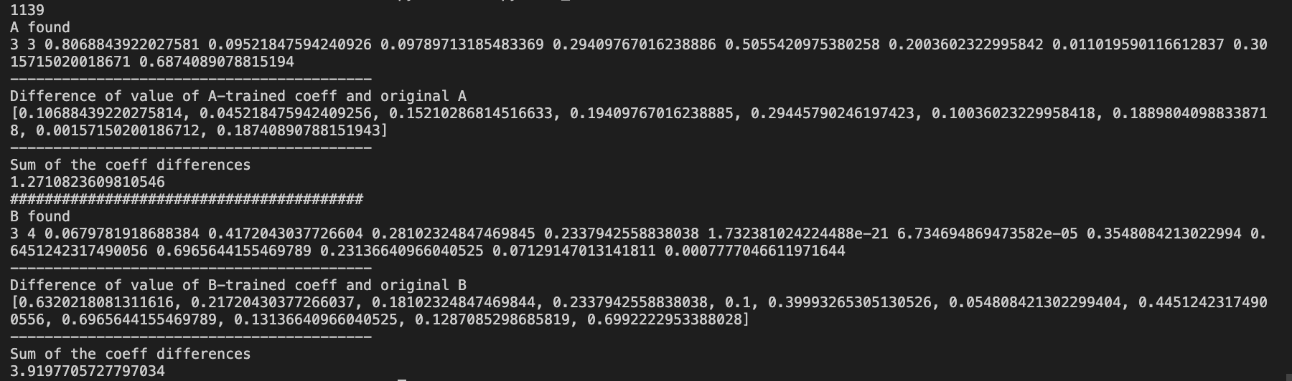

* T = 10000 (stopped after 5min)

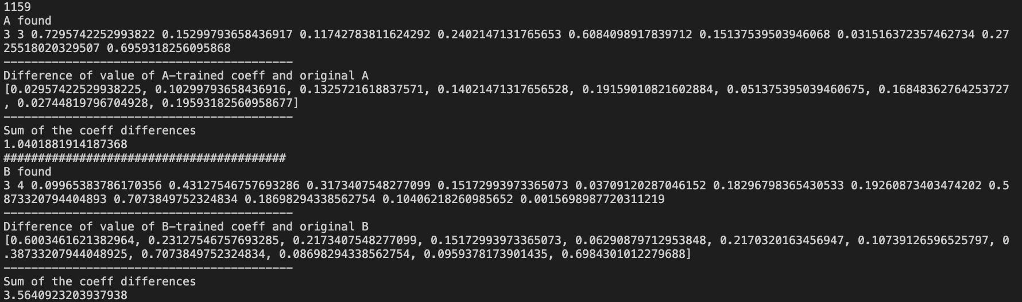

🡪 one or two coefficients may not converge

🡪 use the median of the abs difference between matrices, components-wise.

3)

* More time to converge (more calculations with 4 hidden states)

4)

Uniform distribution:

* T = 1000

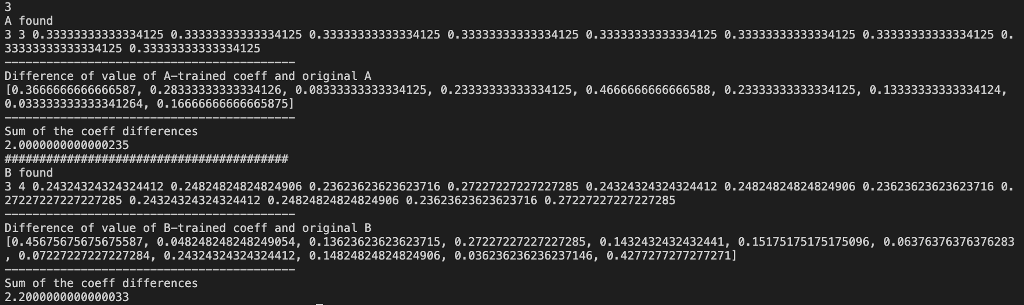

* T = 10000

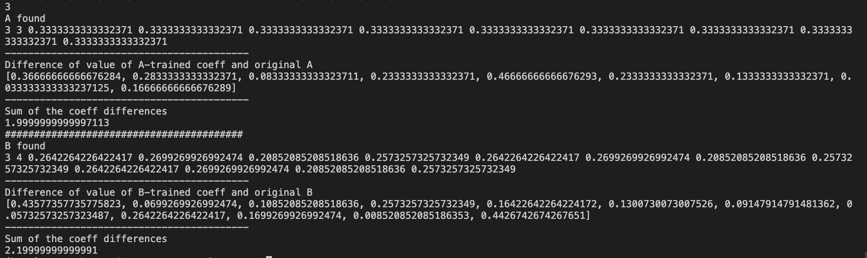

🡪 very fast to converge but not at all accurate

Matrices close to the solution

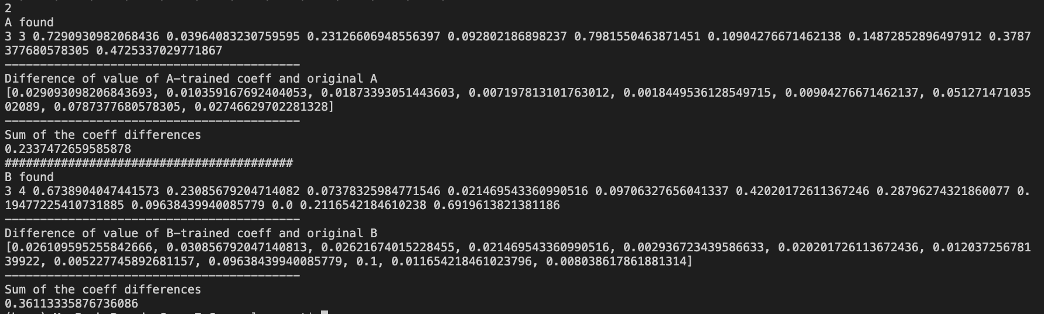

Converge quickly (few steps) and accurate